Transparency: Concepts of Type I, Type II error & power

Type I and Type II Errors

If we reject  (accept 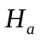) when in fact is true, this is a type I error

If we fail to reject (reject ) when in fact is true, this is a type II error.

Significance level of any fixed level test is the probability of a Type I error. That is, is the probability that the test will reject the null hypothesis when in fact is true.

The probability of a type II error is a little more difficult to find.

We will do this in the following example…

  - Opening a restaurant.

You are thinking about opening a restaurant and are searching for a good location. From research you have done you know that the mean income of those living near the restaurant must be over $45000 to support the type of upscale restaurant you wish to open. You decide to take a simple random sample of 50 people living near one potential location. Based on the mean income of this sample you will decide whether to open a restaurant there. A number of similar studies have shown that = 5000.

- Describe the two types of errors that you might make. Identify which is a Type I error and which is a Type II error.

SOLUTION: FIRST FIGURE OUT WHAT YOUR HYPOTHESES ARE.

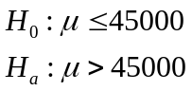

A type one error is if we reject (accept ) when in fact is true
So, a type one error is if we conclude that the mean income is more than 45000 when in fact it is not.

AND A type two error is if we fail to reject (reject ) when in fact is true
So, a type two error is if we conclude that the mean income does not exceed 45000 when if fact it does.

- Which of the two types is most serious? Explain.

SOLUTION: A type one error is more serious because if we conclude that the mean income is more than 45000 and open our upscale restaurant then our business is doomed because the people our potential customers will not be able to afford our prices.

- State the null and alternative hypotheses:

means that the mean income level does not exceed $45000

means that the mean income level exceeds $45000

- If you had to choose one of the “standard” significance levels for your significance test, would you choose 0.01, 0.05, or 0.10?

THINK ABOUT IT!!!!!!!!

The probability of a type one error (an error MORE serious in this case) is equal to .

SO, we want the lowest probability of making this error. Therefore we want the lowest

- Based on your choice in part d, how high will the sample mean need to be before you decide to open a restaurant in that area?

SOLUTION: In order to reject at a level of 0.01, we must have 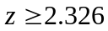 Since 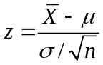, we can now solve for 

can be written 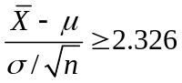

Plug in for and for From the original problem, = 45000 and = 5000

So, 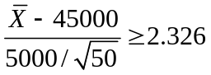 gives 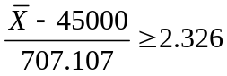 multiply both sides by 707.107 and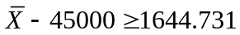 add 45000 to both sides 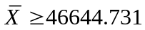
Thereforem our sample mean must be at least $46,645 in order to reject .
- If the mean income in a certain area is $47000, how likely are you not to open a restaurant in that area? What is the probability of a Type II error?

A type II error is when we fail to reject (reject ) when in fact is true.

Now we are being told that the mean of a certain area is 47000 giving us a NEW mean = 47000

We want to know the P( we fail to reject when = 47000) THIS IS A TYPE II ERROR

P( we fail to reject when = 47000) = P(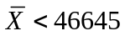when = 47000)

=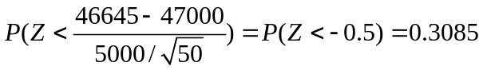

So when = 47000, the probability of a Type II error is 0.3085 or about 31%.

Power

The probability that a fixed level significance test will reject when a particular alternative value of the parameter is true is called the power of the test against that alternative. The power of the test against any alternative is 1 minus the probability of a Type II error.

So, in the previous problem the power against the test was 1-0.3085 = 0.6915

Increasing Power: Suppose that you have performed a power calculation and found that the power is too small. What can you do to increase it? Here are four ways:

- Increase . A 5% test of significance will have a greater chance of rejecting the alternative then a 1% test because the strength of the evidence required for rejection is less.
- Consider a particular alternative that is farther away from 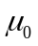. Values of that are in but lie close to the hypothesized value are harder to detect ( lower power) than values of that are far from .
- Increase the sample size. More data will provide more information about so we have a better chance of distinguishing values of
- Decrease . This has the same effect as increasing the sample size: more information about . Improving the measurement process and restricting attention to a subpopulation are two common ways to decrease .

Exercise 10.71 SAT Math Scores: POWER

Exercise 10.55 gives a test of a hypothesis about SAT Math Scores of California high school students based on an SRS of 500 students. The hypotheses are…

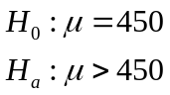

Assume that the population standard deviation is = 100. The test rejects at the 1% level of significance when , where

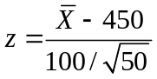
Is this test sufficiently sensitive to usually detect an increase of 10 points in the population mean SAT Math score? Answer this question by calculating the power of the test against the alternative = 460.

FIRST find the probability of a type II error meaning that we want…

P( we fail to reject when = 460) = P(when = 460)

We must find the value of when 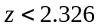

So, since we now have 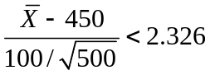
Which gives 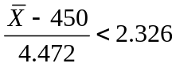 multiply both sides by 4.472 and 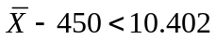 add 450 to both sides 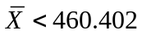meaning that 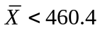

So this gives us

P( we fail to reject when = 460) = P(when = 460) = P(when = 460)

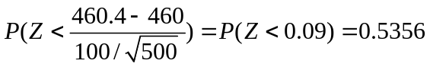

The power is 1-P( Type II error) = 1-0.5356 = 0.4644.

We want at least an 80% power, so a power of about 46% shows that this test is not sensitive to a 10 point increase in the mean score.

